
Configuring and using Smart Links
in Learning Zone
For RNZCGP
By Ray Handley

By

Smart Links
Smart links allow the administrator to create links (within HTML blocks) to various pages within Learning Zone, depending on information in the user’s profile.
Configuring Smart Links
Smart links are configured using the following steps:
- Select Site administration
- Select Users
- Select Smart Link
- Select Configure Smart Links. The following screen will appear (here shown completed):
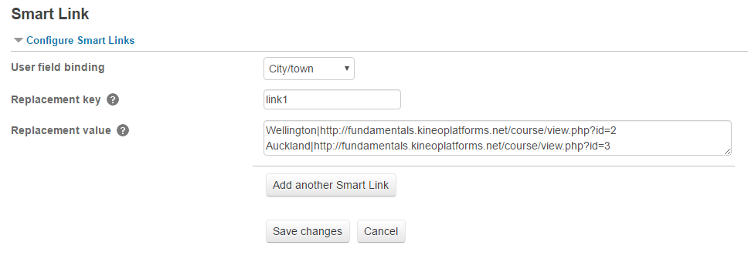
- Select the User field binding e.g. ‘City/town’
- Type in a replacement key e.g. ‘link1’
The replacement key indicates the string that is replaced in the html block. For example, entering "link1" here will cause all instances of "@{link1}" in the html block to be replaced.
- Type the replacement values (separating each one on a new line)
e.g. ‘Auckland Central|course/view.php?id=37’
The replacement value is a line ("|") separated list of "data|value" with each pairing separated by a new line where "data" is the data of the selected user field to bind to and "value" is the replacement text.
- Add any additional smart links by selecting Add another Smart Link.
Note: you can only use one binding field from the user’s profile but can have multiple smart links. This way you can use the same user profile field in a different context.
- Select Save changes
- A message will appear letting you know that your Smart Link has been saved. Select Continue or wait for the page to reload.

The Smart link is now configured.

Using a Smart Link in a HTML block
Smart Links are used in a HTML block to guide a learner/user to a specified location based on an item in their profile field.
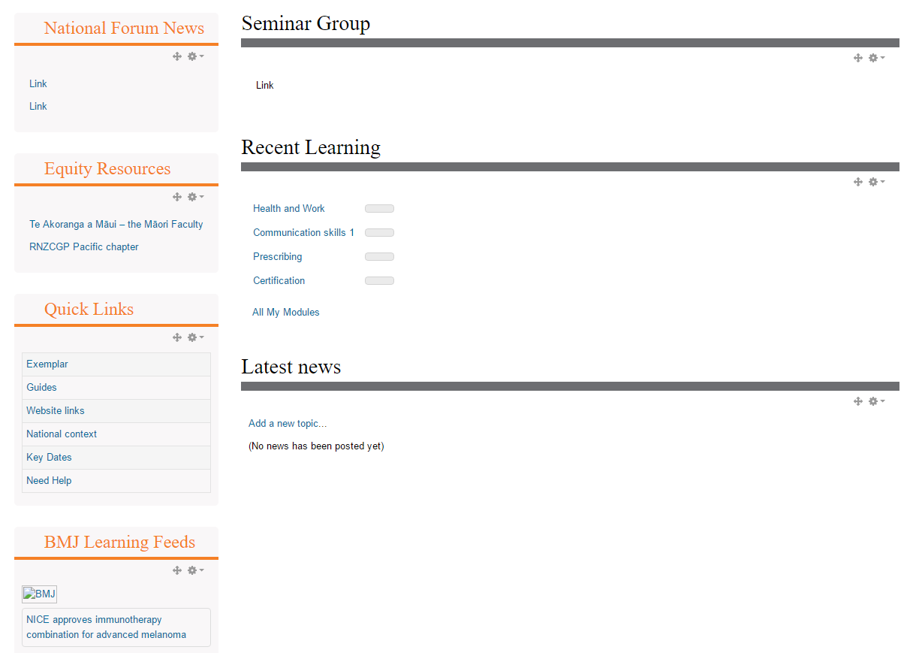
Here we are creating a Smart Link to take the user to their appropriate Seminar Group.
After creating a HTML Block you can configure it using the small cog icon on the right.

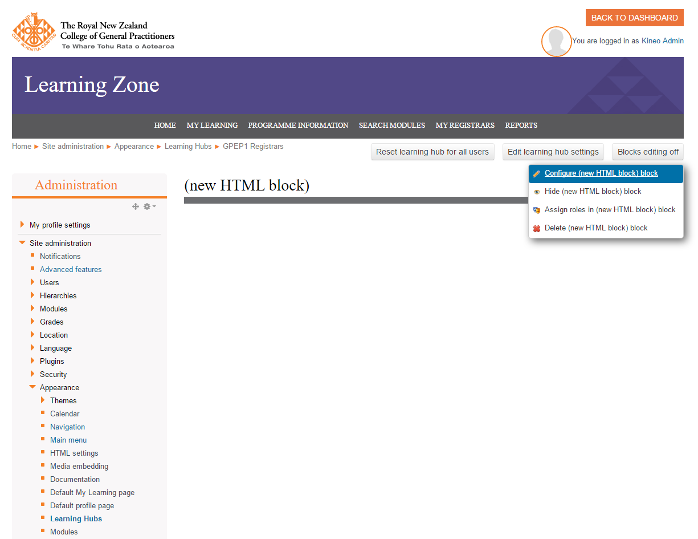
Select Configure (block name) block

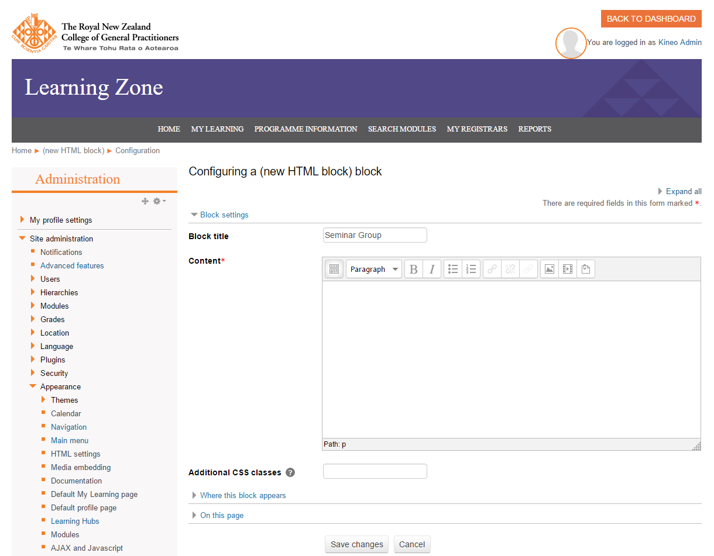
In the Content area select the Toolbar toggle button on the top left
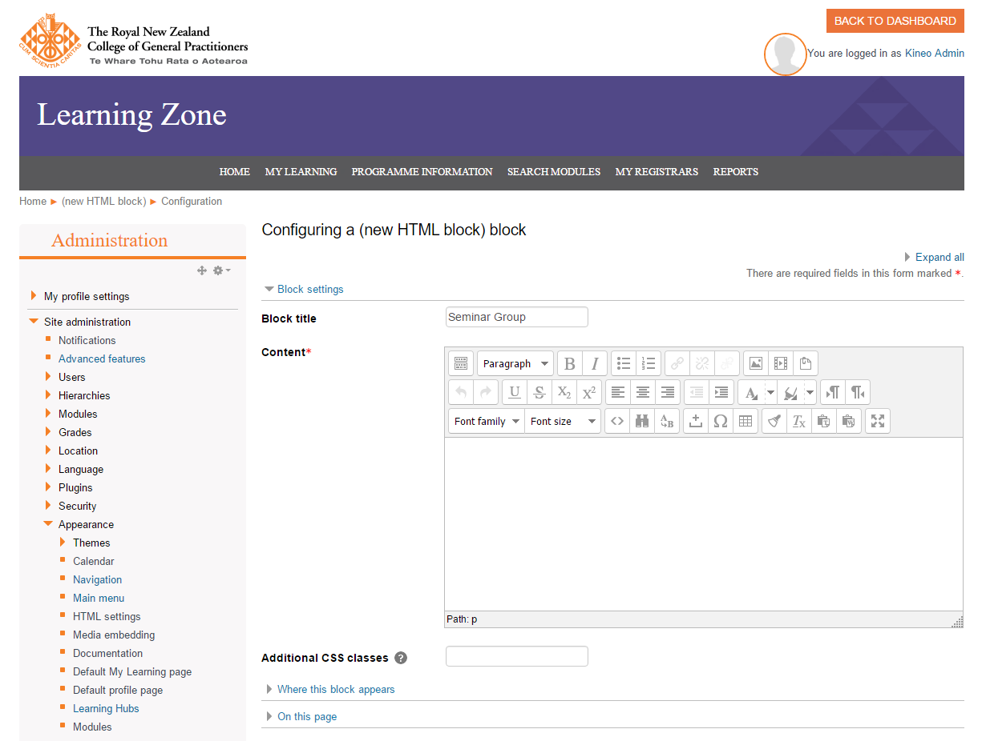
Select the Edit HTML source button

Add the HTML to the HTML source editor window. When referring to the Smart Link you must reference it using the syntax: @{Replacement key}
e.g. @{link1}
In the example below with the words Click here we have created a link to the word here using the replacement key ‘link1’. The HTML for this would be:
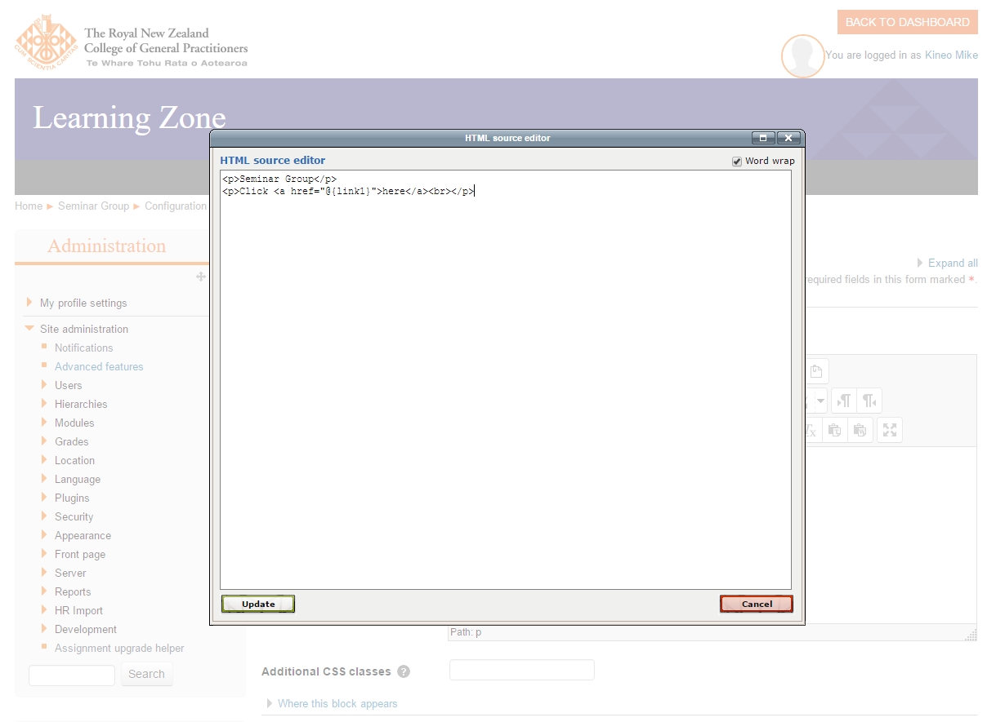
<p>Click <a href=" @{link1}">here</a></p>
After adding the HTML select Update

The Smart link has now been used in the HTML block. In this example the user will select the link and be taken to their Seminar Group based on their City/town field in their user profile.
Important
If the user does not have an entry in their user profile for the binding field, the link will be broken and the user will get a 404 error. You can avoid this by ensuring all users have an entry in their profile field.

